# **Granting Permission to Create Custom Filters in Snowsight**

With the latest Snowflake update, custom filter creation permission can now be authorized for any other roles created in the Snowflake account. This implies that any role with this permission, besides the accountadmin role, is now capable of creating custom filters.

Before proceeding with the actual steps, It is recommended that a user with the ACCOUNTADMIN role (i.e root user) must only grant permission to create custom filters to each role, including the ACCOUNTADMIN role itself.

#### **Follow the steps below to grant a role permission to create custom filters:**

##### Sign into Snowsight.

##### Select **Worksheets** to open the list of worksheets.

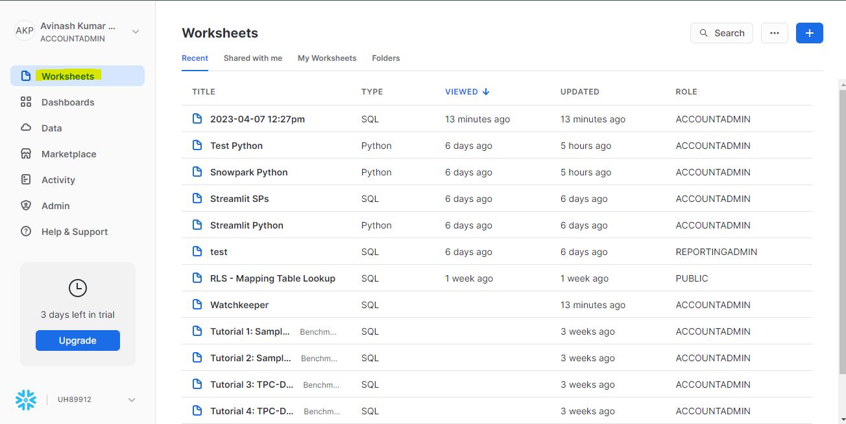

##### Open a worksheet.

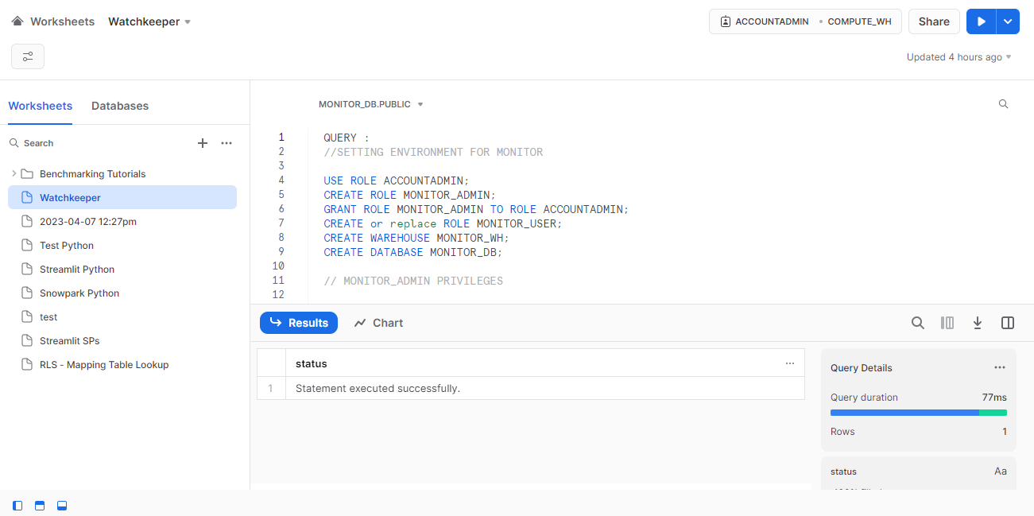

##### Select the **Show or Hide Filter** button and select **Manage Filters**.

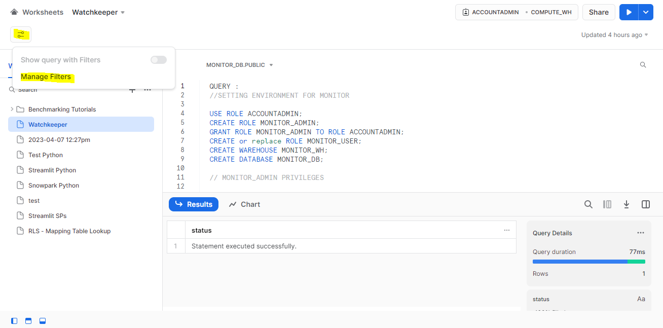

##### In the dialog that appears, select **Edit Permission**.

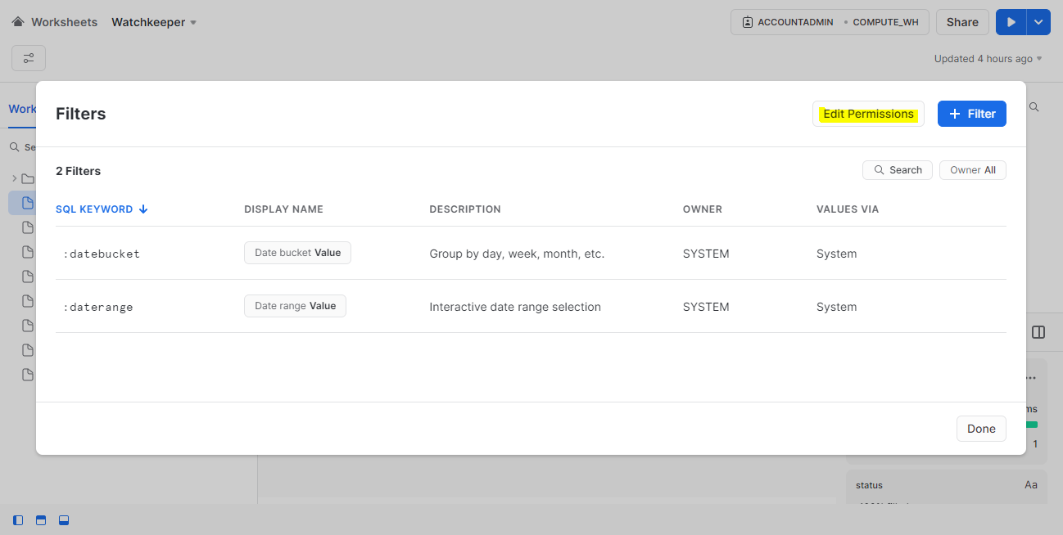

##### In the Filter Permissions dialog, select the roles you want to grant permission to create filters. Select **Monitor_Admin** role for Watchkeeper.

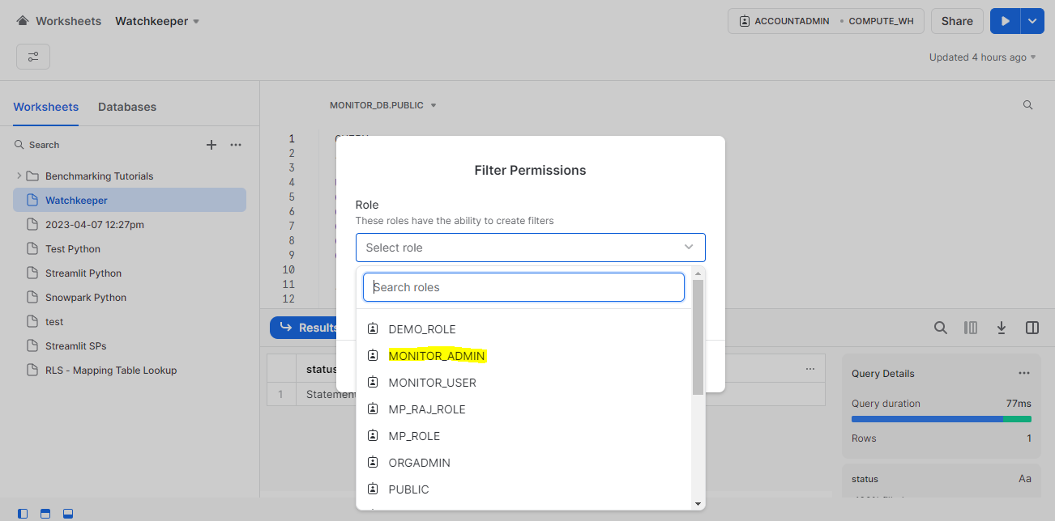

##### Once a role is selected, it will look like this:

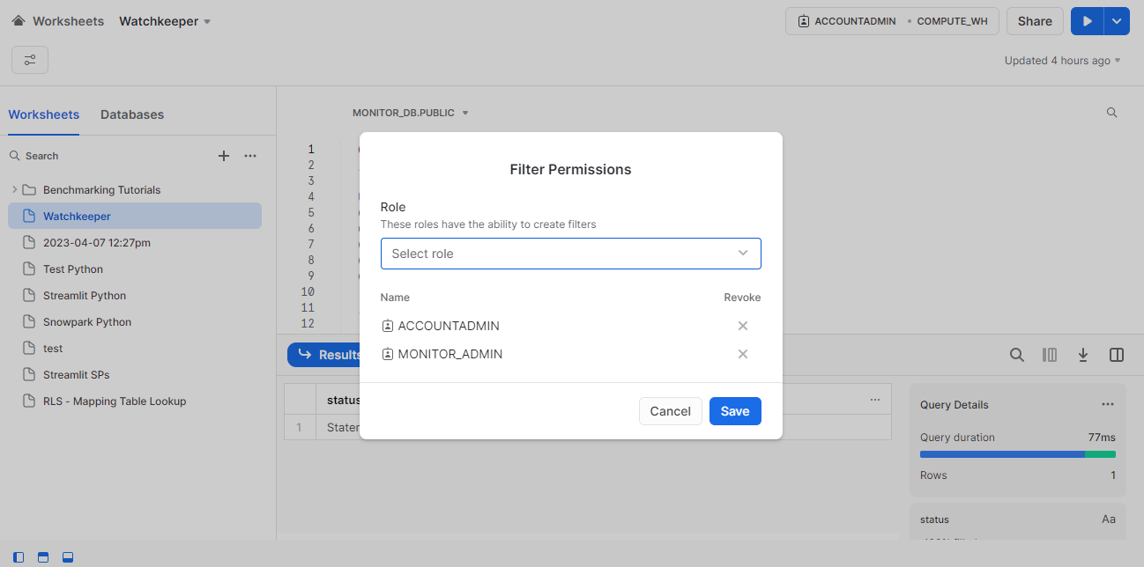

##### Select **Save.**

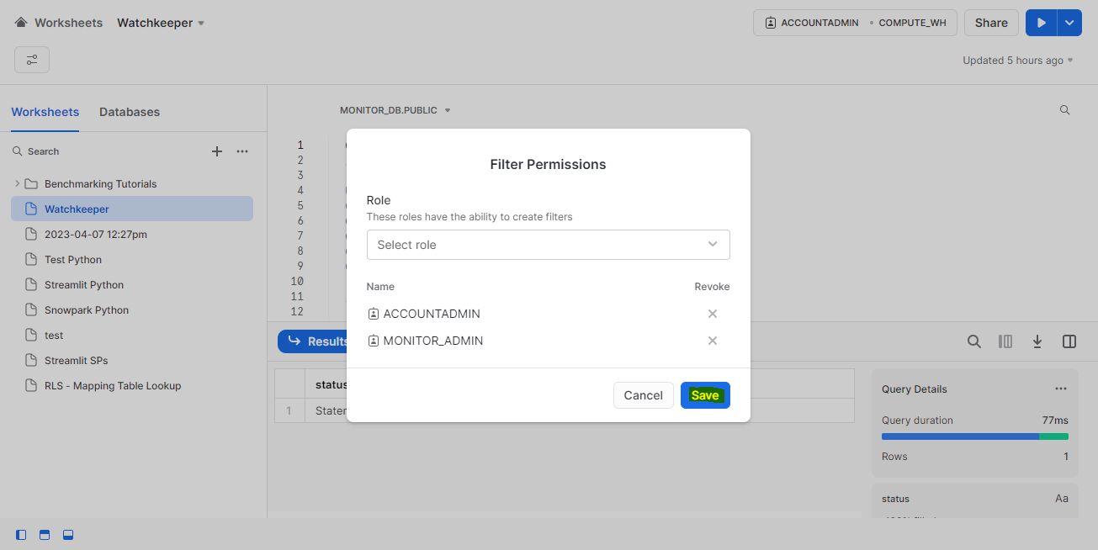

That's all we need to do to grant permission for creating custom filters. If you log in with a user having the custom filter creation permission role, you will be able to see the add new filter button.

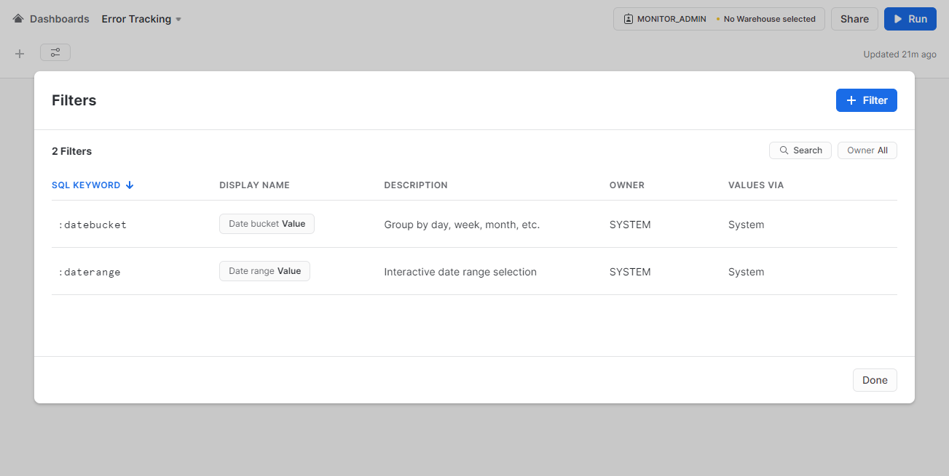

#### **Point to be remembered:**

* Root users (having accountadmin and other roles) are able to see the **edit permission** button for custom filters with any role opted in the current session apart from accountadmin role. Therefore, it's always best practice to assign custom filter permission to the Monitor_Admin role and further assign the Monitor_Admin role to the user who is going to create Watchkeeper Monitoring Dashboards.